**Game Store Project**

**Tyler Burger**

**Davenport University**

**CSCI239**

**February 19, 2020**

**Table of Content**

**1 Game Store …..……………………………………………...………………………. 4**

1.1 Overview ……………………………………………………………………………... 4

**2 Main Window Display …………………………………………….………...….…. 5**

2.1 Main Overview …………………………………………….…………………….…. 5

2.2 Main Display …………………………………………….………………………….. 5

2.3 Main Functionality …………………………………………….………………..…. 6

**3 New Record Menu Button ………………………………….……………………. 8**

3.1 New Overview …………………………………………….………………………... 8

3.2 New Display …………………………………………….…………………………... 9

3.3 New Functionality …………………………………………….…………………... 9

**4 Open Record Menu Button ………………………………..……………..…….. 11**

4.1 Open Overview …………………………………………….……………….……. 11

4.2 Open Display …………………………………………….…………………….….. 11

4.3 Open Functionality …………………………………………….…………….….. 11

**5 Save Record Menu Button …………………………………..……………….... 13**

5.1 Save Overview …………………………………………….……………………... 13

5.2 Save Display …………………………………………….…………….………….. 14

5.3 Save Functionality …………………………………………….………………... 15

**6 Delete Record Menu Button …………………………………………...………. 16**

6.1 Delete Overview ………………………………………….…………….……….. 16

6.2 Delete Display ………………………………………….………………….……... 17

6.3 Delete Functionality ………………………………………….………….…..…. 18

**7 Undelete Record Menu Button ………………………………...………….….. 19**

7.1 Undelete Overview ………………………………………….……………….…. 19

7.2 Undelete Display ………………………………………….……………….…….. 19

7.3 Undelete Functionality ………………………………………….……….….…. 19

**8 Purge Deleted Records Menu Button ………………………..…………..….. 21**

8.1 Purge Overview ………………………………………….………………………. 21

8.2 Purge Display ………………………………………….………………….………. 21

**9 About Menu Button ………………………………………….…………….…….. 22**

9.1 About Overview ………………………………………….……………….……... 22

9.2 About Display ………………………………………….…………………….……. 22

**10 Exit Menu Button ………………………………………….……………….…….. 23**

10.1 Exit Overview ………………………………………….………………….………. 23

**11 Test Case ……………………………………………………………………….…... 24**

11.1 All Functionality Walk-Through …………………………………………….. 24

**1 Game Store**

**1.1 Overview**

This application is for game companies who want to keep track of their point of sales (POS). This application works in conjunction with a database that stores customer information, game product information, and the order details. The customer information that is stored is; Customer_ID, First_Name, Last_Name, Address, City, State, Zip, Phone, and Email. The game information that is stored is; Game_ID, Game_Name, Developer, Genre, Platform, Release_Date, Game_Price, and Game_Quantity. The order detail contains the following information; Order_ID, Order_Date, Delivery_Date, Customer_ID, and Game_ID. The application will provide any end-user with full access to the game stores database. This includes the ability to add a record, open a record, update a record, delete a record, undelete a record, and purge all deleted records. The rest of this user manual will break down each process step-by-step.

**2 Main Window Display**

**2.1 Main Overview**

The main window display is the main hub for all the activity that happens within this application. Upon first glance, the main contains two menu options, eight text fields with corresponding labels, two combo boxes with corresponding labels, and one last label at the bottom of the window. The first text field labeled with “Customer Number” will be disabled from any editing. This is because right now all these items are for just display only. To make them functionality, the user must first go into the menu item “File” then select any of the corresponding menu items to continue; “New, Open, Save, Delete, Undelete, Purge, Exit.” More on what each one does later.

**2.2 Main Display**

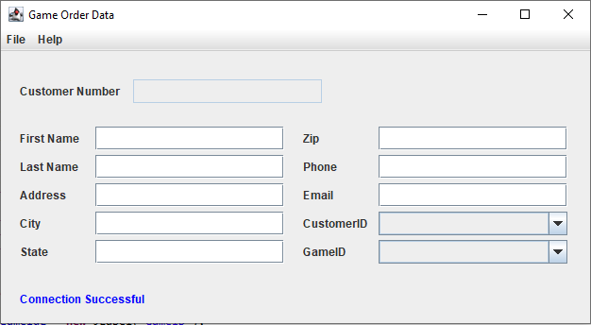

**2.3 Main Functionality**

The “File” menu item contains all the functionality that the user will need.

* The “New” item will open a new window where the user can enter a new record for Order, Customer, or Game.
* The “Open” item will open a new window where the user can select a record from Order, Customer, or Game to open.
* The “Save” item will update the record that the user either just created or opened with the number located at “Customer Number” on the main window.
* The “Delete” item will remove the record that the user either just created or opened with the number located at “Customer Number” on the main window.
* The “Undelete” item will open a new window where the user can select and add back the record that the user just deleted.
* The “Purge” item will permanently remove all the records that have been deleted.
* The “Exit” item will close the application.

Once the user selects either “New” or “Open” and navigates through those windows, the application will lead back to the main window. If the user decides to enter a new order, all the labels will change to represent order rather than customer. For example, “Customer Number” will change to “Order Number” and the order Number will automatically be entered within the corresponding text field. The box is still disabled for editing so there’s no issues with the database. The rest of the labels will change to match what the database stores for Order. The text field/combo boxes that aren’t needed for what the user is using will be disabled.

**3 New Record Menu Button**

**3.1 New Overview**

Pressing the “New” menu button will display a new window called New Record where users can insert a new record into the database. The new window contains radio buttons for Order, Customer, and Game, buttons for enter and cancel, text field for entering a new ID, and a text area that displays the records already in the database. The user can select between Order, Customer, and Game to populate different data in the text area. After a record has been entered, the application redirects the user back to the main window.

**3.2 New Display**

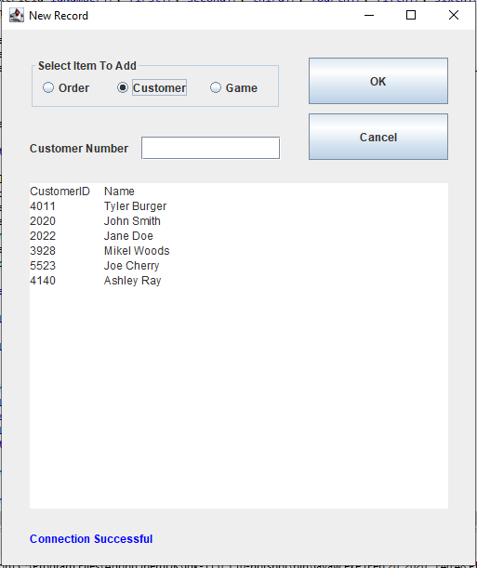

**3.3 New Functionality**

The radio buttons allow the user to interact with the different tables in the database; Order, Customer, Game. By selecting a radio button, the label will change to correspond with the radio button. For example, if the user selects the “Order” radio button, then the label will change to “Order Number”. The text area will also populate different data depending on which radio button the user selects. Order displays OrderID, CustomerID, and GameID. Customer displays CustomerID, First_Name, and Last_Name. Game displays GameID, System, and Title. If the user tries to enter a new record without entering a number, the application will then populate a message showing no record found. Once a record has been entered, the application will redirect the user back to the main window.

**4 Open Record Menu Button**

**4.1 Open Overview**

Pressing the “Open” menu button will display a new window called Open Record where users can search for a record a open the record back in the main window. This window is very similar to the New Record window except instead of a text field, there’s now a combo box to select records from. Unlike the New Record window, there isn’t any text area displaying record information. The combo box only contains the ID numbers of Order, Customer, and Game. After a record has been selected, the application redirects the user back to the main window.

**4.2 Open Display**

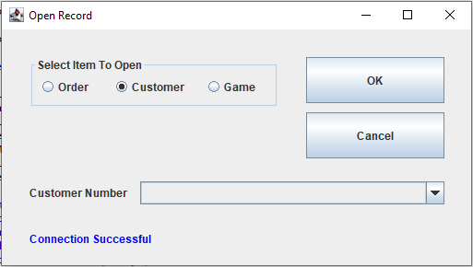

**4.3 Open Functionality**

The radio buttons allow the user to interact with the different tables in the database; Order, Customer, Game. By selecting a radio button, the label will change to correspond with the radio button. For example, if the user selects the “Order” radio button, then the label will change to “Order Number”. The combo box will only populate the ID numbers for the corresponding radio button. If the user tries to click the enter button without selecting a ID number, the application will display a message saying that no record can be found. Once the user selects an ID number from the combo box and clicks enter, the application will redirect the user back to the main window.

**5 Save Record Menu Button**

**5.1 Save Overview**

Pressing the “Save” menu button will update the record to the database. Unlike New Record and Open Record, the Save menu button will not open a new form but rather a pop-up message. The pop-up message will either state the record has been successfully updated or record cannot be found. The save is driven off the main windows text fields and if the ID label is for Order, Customer, or Game.

**5.2 Save Display**

If ID number is found:

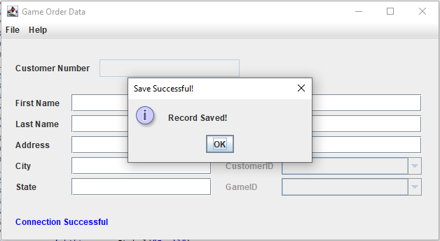

If ID number isn’t found:

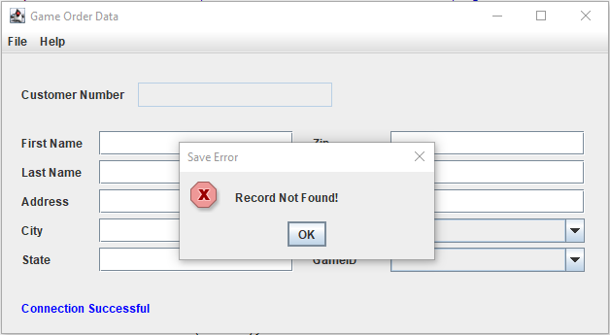

**5.3 Save Functionality**

The driving force for the save functionality of the application is with the label stating Order, Customer, or Game along with the text fields. If the ID number is not contained in the ID number text field, the application will be unsuccessful with the update SQL and return the message saying ID number cannot be found. As long as an ID number is present within the ID number text field, the save menu button will work properly. Once the record has been successfully updated, the application will clear all the text fields so the user can perform other activities.

**6 Delete Record Menu Button**

**6.1 Delete Overview**

Pressing the “Delete” menu button will delete the record from the database. Unlike New Record and Open Record, the Delete menu button will not open a new form but rather a pop-up message. The pop-up message will either state the record has been successfully deleted or record cannot be found. The delete is driven off the main windows text fields and if the ID label is for Order, Customer, or Game.

**6.2 Delete Display**

If ID number is found:

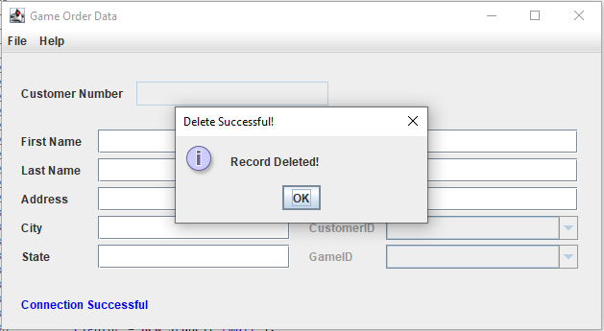

If ID number isn’t found:

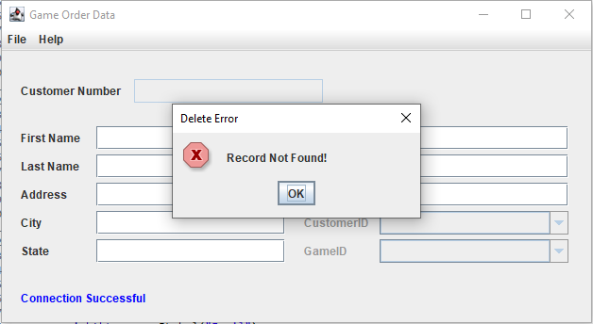

**6.3 Delete Functionality**

The driving force for the delete functionality of the application is with the label stating Order, Customer, or Game along with the text fields. If the ID number is not contained in the ID number text field, the application will be unsuccessful with the delete SQL and return the message saying ID number cannot be found. As long as an ID number is present within the ID number text field, the delete menu button will work properly. The delete menu doesn’t only remove the record from the table, but it also moves the record to a Temp table. For example, if the user decides to delete the order number: 100632, this order number will be inserted from the Order table to the Temp_Order table with all it’s corresponding data. This will be further explained in the undelete functionality. Once the record has been successfully deleted, the application will clear all the text fields so the user can perform other activities.

**7 Undelete Record Menu Button**

**7.1 Undelete Overview**

Pressing the “Undelete” menu button will open a new window where the user can undelete a recently deleted record. The window is identical to the Open Record window, undelete contains all the same radio buttons, combo box, and buttons. However, instead of populating the text fields of the main window, the undelete works behind the scenes. Once a user has selected an ID number and clicks the enter button, the application will display a pop-up message stating that the record was successfully undeleted and redirect the user back to the main window.

**7.2 Undelete Display**

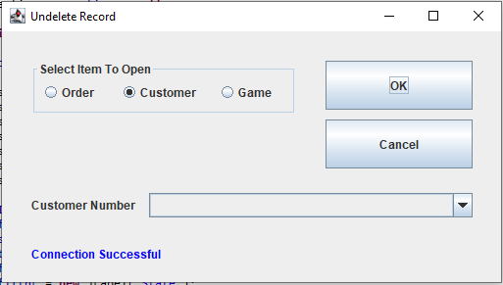

**7.3 Undelete Functionality**

The radio buttons allow the user to interact with the different tables in the database; Temp_Order, Temp_Customer, Temp_Game. By selecting a radio button, the label will change to correspond with the radio button. For example, if the user selects the “Order” radio button, then the label will change to “Order Number”. The combo box will only populate the ID numbers for the corresponding radio button. If the user tries to click the enter button without selecting a ID number, the application will display a message saying that no record can be found. When the user selects an ID number and clicks the enter button, not only will the application move the record back to it’s previous table, but also deletes that record from the Temp table. For example, if the user were to undelete a record from Temp_Order the record would first be inserted back into Order then deleted from Temp_Order. Once the SQL has been executed, a pop-up message will appear saying the undelete was successful and redirects the user back to the main window.

**8 Purge Deleted Records Menu Button**

**8.1 Purge Overview**

Pressing the “Purge” menu button will permanently delete all the records within the Temp tables. Clicking purge will display a pop-up message asking the user if they are sure if they want to purge the data. After clicking yes or no, the application redirects back to the main window.

**8.2 Purge Display**

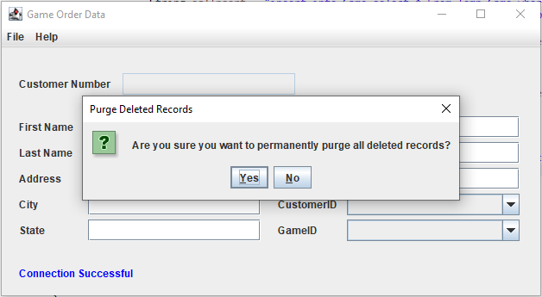

**9 About Menu Button**

**9.1 About Overview**

Unlike all the other functionality in this program, the about functionality can only be accessed through the “Help” menu item instead of “File”. The about is just a simple pop-up message stating information about the application. This includes the Game Store Project GUI, author, class, and year. The pop-up also has an ok button to exit the pop-up and go back to the main window.

**9.2 About Display**

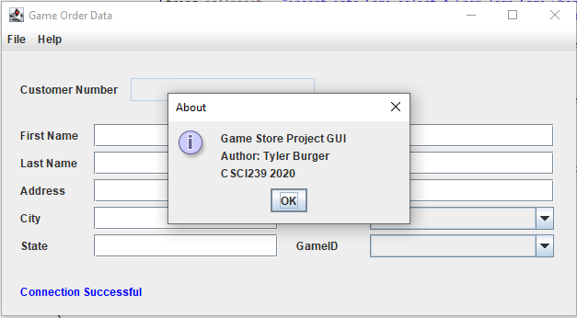

**10 Exit Menu Button**

**10.1 Exit Overview**

Pressing the “Exit” menu item will terminate the application. The application can also be closed through the red x at the top right corner. There’s no display for the exit button, unlike the other buttons which either displayed another window or pop-up message.

**11 Test Case**

**11.1 All Functionality Walk-Through**

Follow the scenario below to understand how to properly use all the functionality that the application has available for the user.

1. Go to File => New
2. Then once the New Record window displays click the Order radio button and enter the Order Number of 95000. Then click the OK button.

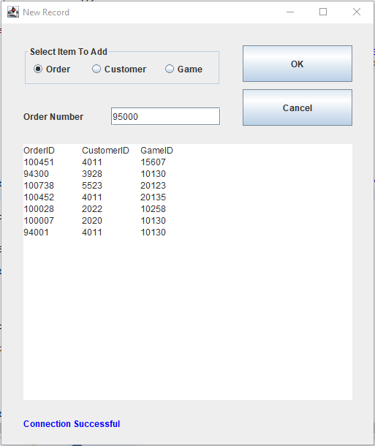

1. After clicking OK, the application should redirect you back to the main window. The text fields should represent the data based on Order and the ID Number you entered should be displayed as the Order Number. Enter the following information in the corresponding text fields/combo boxes; Order Date = 2020-2-20, Delivery Date = 2020-2-25, Price = 64.99, CustomerID = 4011, GameID = 10130.

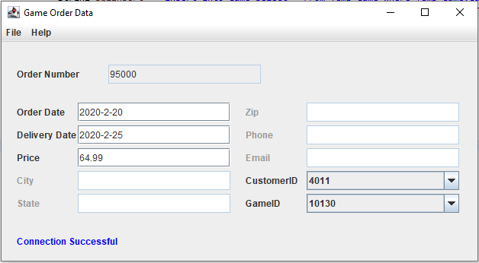

1. After entering the data, goto File => Save. This will save the data you just entered into table Order and clear all text fields/combo boxes.

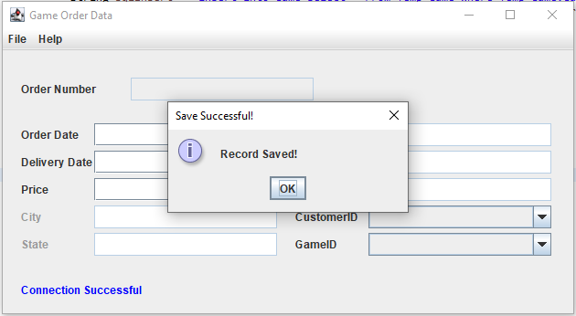

1. Now goto File => Open
2. Once the Open Record window displays, select the Order radio button and in the combo box drop down select 95000. Then click the OK button.

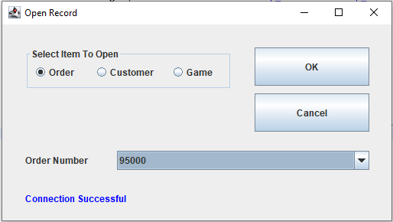

1. After clicking the OK button, the application will redirect you to the main window with all the data you just filled out. Now goto File => Delete. This will delete the data from the Order table (and move to the Temp_Order table). A pop-up will appear stating “Record Deleted!”. Press the OK button.

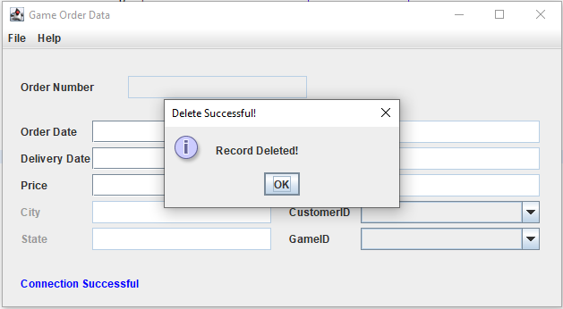

1. Now goto File => Undelete.
2. Once the Undelete Record window appears, select the Order radio button and in the combo box drop down select 95000. Then press the OK button.

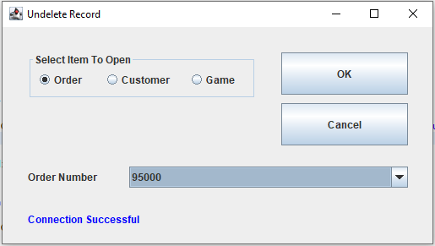

1. A pop-up will appear saying “Undeleted Record”. Press the Ok button and the application will redirect you to the main window. From here repeat the process of opening that same record and deleting. After deleting record 95000 again, proceed to step 11.
2. Now goto File => Purge. A pop-up will then appear asking you want to permanently purge all deleted records. Click the Yes button.

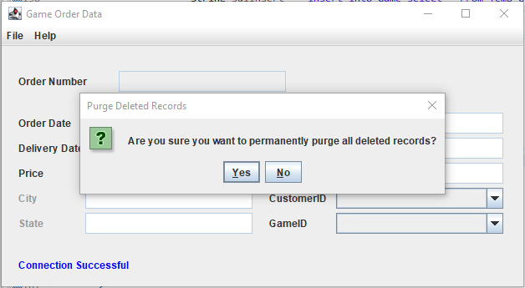

1. Great Job! You have successfully added a record, searched and opened a record, updated a record, deleted a record, undeleted a record, and purged deleted records. Feel free to repeat the process for Customer Number and Game Number. Note: Customer and Game will have different text fields to account for.
2. Once your done testing goto File => Exit to terminate the application.